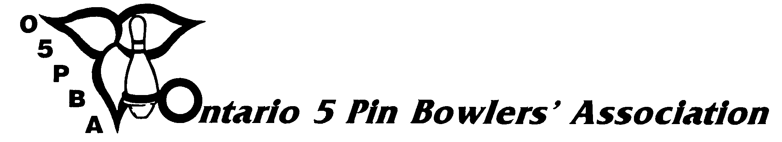
3 Concorde Gate, Suite 302, Toronto, Ontario, M3C 3N7
Telephone: (416) 426-7167 Fax: (416) 426-7364 E-Mail: o5pba@o5pba.ca Website: www.o5pba.ca

2011-2012 O5PBA YEAR-END AWARDS
- ORDER FORM -

ZONE/DC ASSOCIATION:
AWARDS CHAIR:

STREET ADDRESS:

CITY/TOWN: POSTAL CODE:

**************************************************************

Our Zone/DC Association would like to order the following items:

Quantity Description Price Total

________ Merit Bar with Pin $5.00 $_________

________ League Champion Pin $1.50 $_________
Total Amount: $_________

13% HST: $_________

Shipping & Handling: $ 5.00

GRAND TOTAL: $ _________

Please enclose a cheque made payable to the "Ontario 5 Pin Bowlers' Association" with your order.

INCENTIVE POINTS WILL BE AWARDED FOR THOSE ASSOCIATIONS WHO PLACE AN ORDER ON OR BEFORE MARCH 2, 2012.

